Fable RSS Reader v1.0 User Manual

1 Overview
Fable is a RSS reader written in Java for multiple platforms. The name “Fable” is derived from “Feed-able”, the ability to retrieve content from multiple sources and aggregate them. The goal of Fable is to be a feature packed, and easy to use program that becomes the one stop source for a user’s daily news needs.
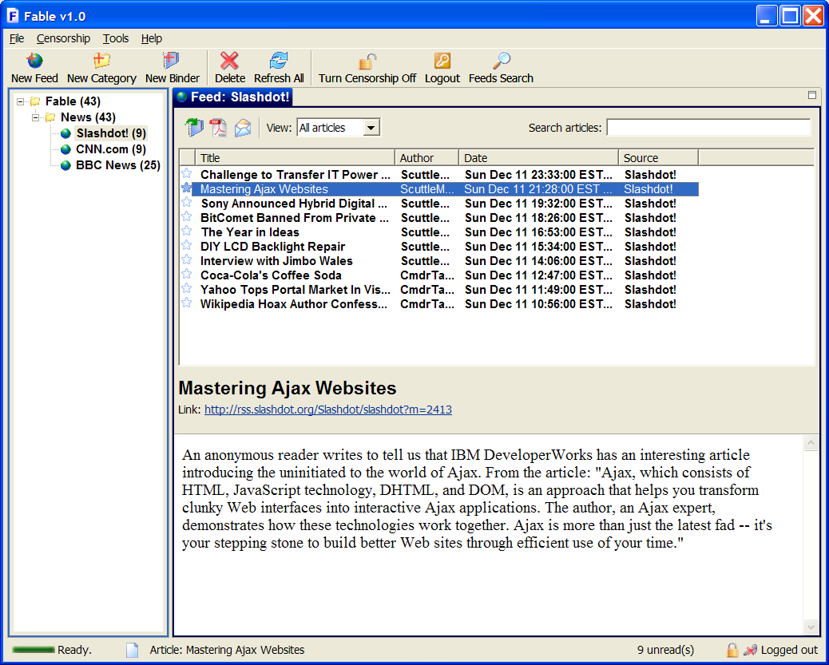

1.1 Features
Fable has full support for RSS content that conform to the RSS 0.9, RSS 1.0, RSS 2.0, and Atom 0.3 specifications. In addition to allowing the user to view feeds in these formats, Fable also supports the caching of articles (both summary and full source) for convenient offline viewing. Fable is able to automatically check subscribed feeds periodically, and silently retrieve new articles in the background.

In addition to these basic features, Fable has the ability to incrementally search articles (both in the summary and full source) for specific queries. To assist the user in quickly viewing specific types of feeds, Fable has a filtered view feature that can be used to show only articles of specific attributes (such as read/unread status, date, etc). It is also easy to filter by a custom combination of attributes. Related to the idea of filters, Fable also has the ability to censor articles according to a list of keywords or domain names.

In addition, Fable also contains several advanced feature. First is the ability to create “binders”, a customized container of articles. This gives the user more freedom to save articles from different feeds into a single location. The second feature is the ability to view a selection of articles as PDF file. This allows the user to easily peruse article summaries, and print or save them with ease. Finally, Fable contains a built in browser, which allows the user to visit links from articles easily within the program.

1.2 System Requirements
The following is a list of recommended system requirements:
Operating System | Windows, Mac OS, Linux
CPU Speed | 300 MHz or higher
Memory Requirements | 128 MB of RAM or above
Java Runtime | 1.5/5.0 or higher

2. Feature Descriptions
Fable has many features to help you with your daily news needs. Here the usage of each will be explained.

Shown below are the different components of the Fable interface, they will be referred to by these names from here on:
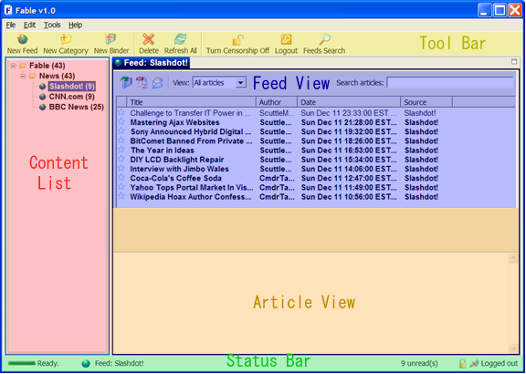

This is the status bar of Fable. It displays information about the running state of the program:
- The left most icon shows whether Feeds are currently being updated or not.
- To the right is an icon and description of the last Feed/Binder/Category/Article that is selected or deleted
- To the right is an description of how many unread articles are contained in the currently selected Feed/Binder/Category
- The right most icons indicate whether censorship is on or off, and whether the user is currently logged in or out.

2.1 Basic Features
Subscribe to RSS Feed:
Subscribing to RSS Feeds allow Fable to retrieve articles from these sources for your viewing pleasure. You could subscribe by typing in the URL of the Feed if you know it. Or if you don’t, you could simply use the Search feature and find the Feed you’re looking for. Alternatively, you could load from a local file.

Instructions: Click on the New Feed button in the toolbar to bring up the dialog box. In the dialog box, click the button next to the method you would like to use to add the Feed:
- Enter URL: Type or paste the address of the Feed
- Load from File: Click the Browse… button and select the file you would like to load
- Search the web: Click on the Search… button. A new dialog box will appear. Type in the topic or Feed you would like to find and click Search. Select from the list of returned results, and click Ok.
Type in a name for the Feed, and select the category under which the Feed is to be added under, and click Ok.

Alternatively: You may also select File | Add | New Feed in the menu to bring up the dialog box. Also, you could right click in the Content List area, and select New Feed in the context menu.
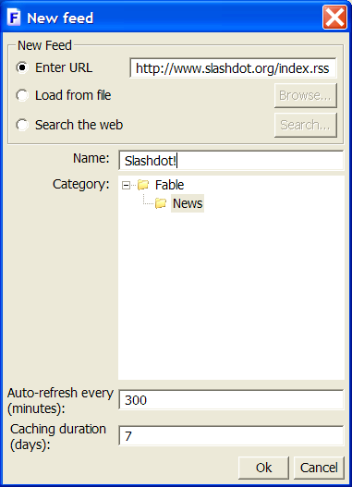

Create a new Category:
To organize Feeds and binders into groups, categories may be added. Categories behave like folders; they can contain Feeds, binders or other categories. For example, you could organize Feeds from Slashdot, CNN, and BBC into a “News” category.

Instructions: Click on the New Category button in the toolbar to bring up a dialog box. In the dialog box, type the name for the Category you would like to create, and select the parent Category. Click Ok.

Alternatively: You may also select File | Add | New Category in the menu to bring up the dialog box. Also, you could right click in the Content List area, and select New Category in the context menu.

Create a new Binder:
Binders allow you to organize articles from different Feeds in a customizable fashion. They allow you to “clip” articles from many sources, and collect them into one place. For example, you could put articles from Slashdot, CNN, and BBC describing a recent election into a Binder called “Election”. This way, you could easily find all articles about a particular topic.

Instructions: Click on the New Binder button in the toolbar to bring up a dialog box. In the dialog box, type the name for the Binder you would like to create, and select the Category under which the Binder is to be added. Click Ok.

Alternatively: You may also select File | Add | New Binder in the menu to bring up the dialog box. Also, you could right click in the Content List area, and select New Binder in the context menu.

Organize Feeds, Binder and Category:
Feeds, Categories, and Binders can be reordered in the Content List. They can be moved from one category to another.

Instructions: Drag the Feed/Binder/Category you would like to move and drop it at the new desired location. To move a Feed/Binder/Category in the same Category up or down, right click in on them and select Move Up or Move Down in the context menu.

Delete Feed/Category/Binder:
Occasionally, a Feed/Binder/Category may no longer be needed, it can be deleted.

Instructions: Select the Feed/Binder/Category that you want to delete, and click on the Delete button in the toolbar. A confirmation dialog will appear, click Yes if you’re sure you want to delete.

Alternatively: You may also select File | Delete in the menu.

Rename Feed/Category/Binder:
Occasionally, you may feel the need to rename a Feed/Binder/Category, you may do so quite easily.

Instructions: Right click on the Feed/Binder/Category that you want to delete, and select Rename in the context menu. Type the new name, and press Enter on the keyboard or simply click anywhere else.

Viewing Articles:
Articles contained within a Feed/Binder/Category can be viewed.

Instructions: Click on a Feed/Binder/Category. All articles contained within it are shown in the Feed View. Click on one of the listed articles to view its summary in the Article View.

Viewing Article Source (Full Article):
The full source (full article) can be viewed in the browser.

Instructions: Click on the link in the Article View. The source will be opened in a new browser tab.

Alternatively: Double clicking on an article in the Feed View will open its source in a new browser tab. Also, you could right click in the Feed View, and select Open Article(s) in Browser. Note that if multiple articles are selected, multiple browser tabs will be opened.
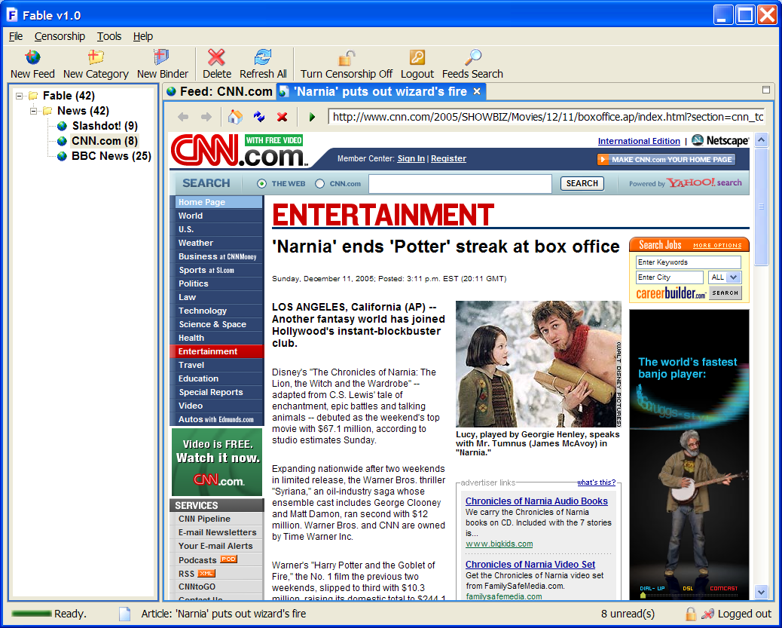

Star Articles
Sometimes, when you come across an interesting article, it would be nice to remember it so you could come back to it. With Fable, this is easily done by marking the article with a star. This will mark it with a star icon, allowing you to easily identify it visually.

Instructions: Click on the star icon next to an article you find interesting. If you click on the icon again, it will remove the star.

Alternatively: Right click in the Feed View, and select Mark As Starred to star the selected articles or Mark As Unstarred to remove the star on the selected articles. Note that multiple articles can be starred or unstarred in this method.

2.2 Advanced Features
Import OPML:
OPML contain lists of RSS feeds. To add Feeds contained within an OPML file, you can import it.

Instructions: Click File | Import | from OPML file in the menu. On the dialog that appears, click Browse to select the OPML file that you wish to import. A list of Feeds contained within that file should appear in with checkboxes next to them. Select the Feeds you would like to import, press the Select All button if you would like to select all Feeds. Select the Category that you would like to import them under and click Ok.
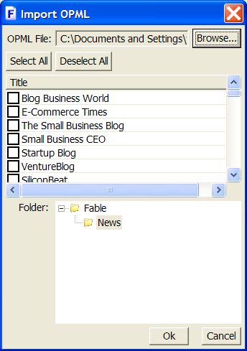

Export OPML:
You can also export your current feeds as an OPML file. You could then send your favorite feeds to a friend or use the OPML file simply as backup.

Instructions: Click File | Export | to OPML file in the menu. On the dialog that appears, click Browse and choose a location and a file name to save your file. Then select the Feeds that you want to export. Click Ok when you’re satisfied with your choices.
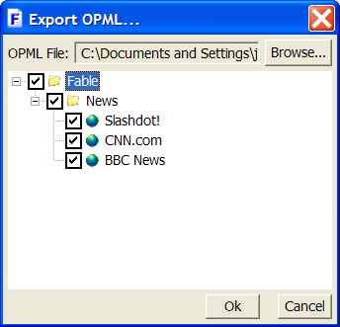

Import/Export Settings:
Sometimes, it is desirable to save all settings and Feeds in Fable. This is valuable both as a backup tool, and could be used if you want to set up Fable on another computer in just the same fashion as the present one.

Instructions: To export settings file, click File | Export | Settings, and choose a location to save the file. To import settings file, click File | Import | Settings, and file the settings file that you would like to load. A warning: loading a settings file will overwrite all current settings with the settings from the file.

Incremental Searching:
Incremental search allows you to quickly find all articles that contain a particular keyword. For example, if you wanted to find all articles that mention the Chicago Bulls, you could type “Bulls” into the search field.

Instructions: Type the words you want to search for in the search field in the Feed View. As you type, results matching your query will appear in the Feed View. As you continue typing, your search will become more refined. Note that as you start typing, minor slowdown might occur, this is due to Fable indexing all articles to process your search.
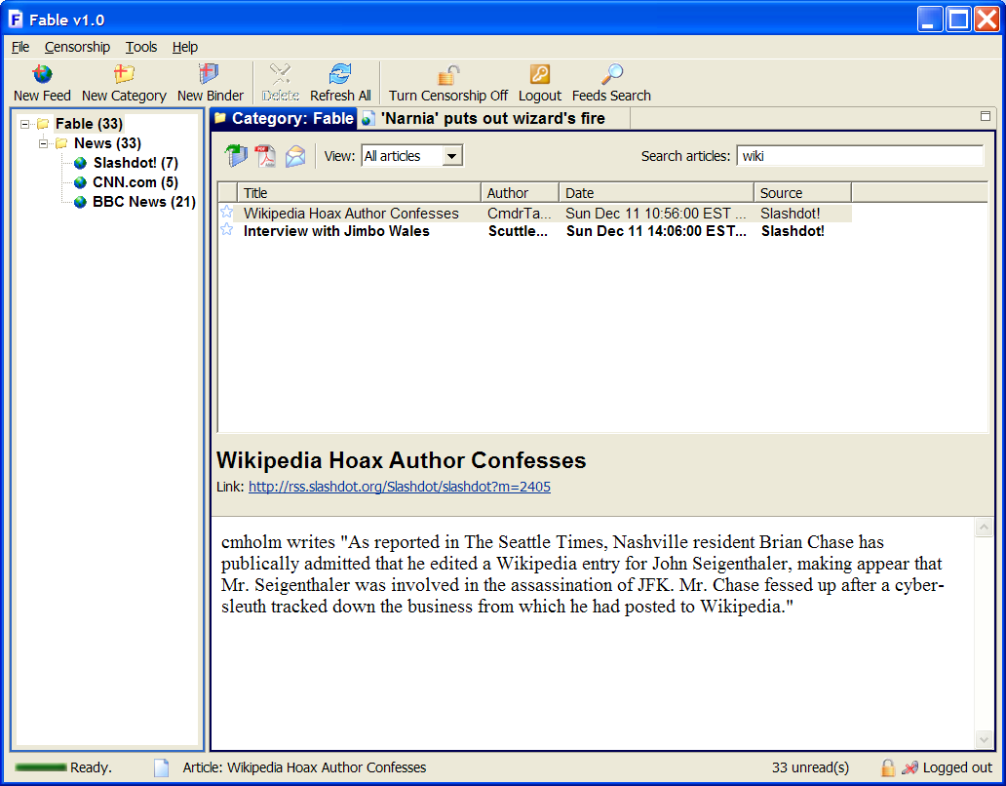

Filtered View:
Fable allows filtering a view by certain categories. For example, you can view only starred items, or only new articles released in the last 7 days. Beside the default categories, you can customize your filter.

Instructions: Select a criterion from the combo box next to the word “View:” in the Feed View. Depending on your selected criterion, the desired results should appear. If you selected “starred only”, only starred articles contained within the current view will be shown. You can also select “custom”, and select the combination of categories that you want to filter by and click Ok. This will display only articles matching the parameters you set.

Content Filter or Censorship:
To prevent potentially objectionable phrases from appearing on screen, Fable has the ability to filter content before they’re displayed. When Fable is started for the first time, it will prompt for a password to be entered. This is the password that will be used to toggle content filter settings in the future.

Instructions: Upon starting, the content filter setting is automatically turned on. By default, it does not filter anything. To edit censorship settings, click on Censorship | Censorship Settings. A dialog box will appear. Add or remove any keywords or domain names by clicking on the appropriate buttons. You can also change your password here, by clicking Change Password. Click Ok when you’re finished. Now articles containing these phrases or are from these domains will not be visible.

To turn off censorship, and make all material visible again, click on the Censorship | Turn Censorship Off button in the toolbar. You will be prompted to enter the password again. Enter it correctly, and censorship will be turned off.
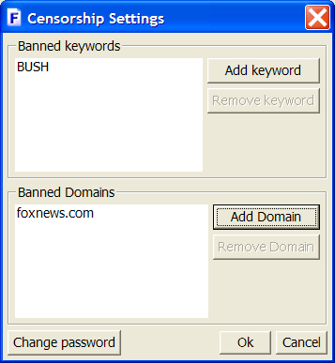

View as PDF:
Fable allows you to view article(s) as PDF documents. This allows you to easily scan the synopsis of many articles in an organized view, and also allows easy printing.

Instructions: Right click on the article(s) that you want to preview, and click View as PDF. A new browser tab with the PDF file containing summaries of the selected articles will be loaded. You can save the PDF if you wish by clicking on the Save icon on the PDF toolbar. You can also print the document by clicking on the Print icon.

Alternatively: Click on the View all as PDF button on the toolbar in Feed View. This will open a new browser tab with the PDF file containing summaries of all articles in the view.
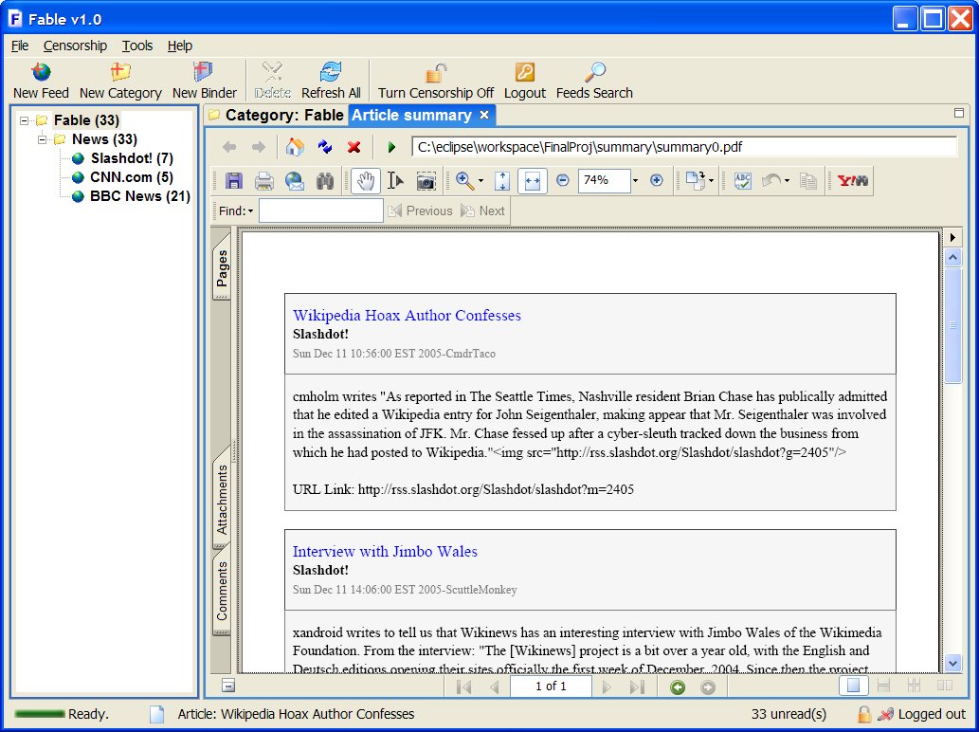

Email Articles:
When you come across interesting articles, it would be nice to be able to notify a friend about it. Fable allows you to send articles via email.

Instructions: Right click on the article(s) that you want to send, and click Email Article(s) on the context menu. A dialog will appear, with the article(s) you wanted to send already in the body. Fill in the Name field with your name, and the To field with the email address of the person you wish to send to. You may edit the Subject and Body of the email as desired. Check “Attach PDF” if you want to attach a PDF file containing the selected article as well. Also, select if you want the email to be sent as a text file or html file. Click Send to send the email.
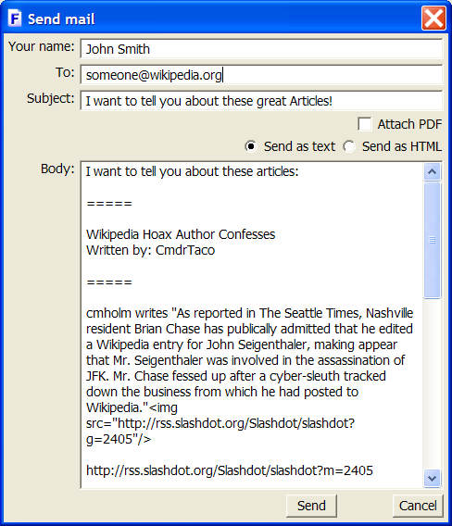

3. Troubleshooting
1. Why does Fable ask me for a password?
Fable contains the feature of censorship. The first time it starts up, it will prompt for a master password, with which the user can control the censorship settings. After that, each time the user wishes to change settings, the password prompt will appear.

2. I added a Feed, but it contains no articles, why?
There could be several reasons for this. It could be that the address of the feed was entered incorrectly. If that is not the case, it is possible that no new articles have been posted to the feed recently.

3. The URL of my article disappeared, what do I do?
Sometimes, text can disappear, simply click on the component or resize it.

4. References and Links
Fable Homepage – http://stuff.mit.edu/~chrismoh/Fable

RSS 1.0 Specification - http://web.resource.org/rss/1.0/spec

RSS 2.0 Specification - http://blogs.law.harvard.edu/tech/rss

Atom 0.3 Specification - http://www.atomenabled.org/developers/syndication/atom-format-spec.php

OPML Specification - http://en.wikipedia.org/wiki/OPML

