EKF report

After reviewing the EKF materials and running the software, in this report I would like to discuss the two major drawbacks of EKF

1. Linearization error
2. Noise tuning

In the following content, I’ll use my personal experience or viewpoint from some literatures I’ve studied to discuss the two issues.

1. Linearization error

Here is the graph from the lecture slides.

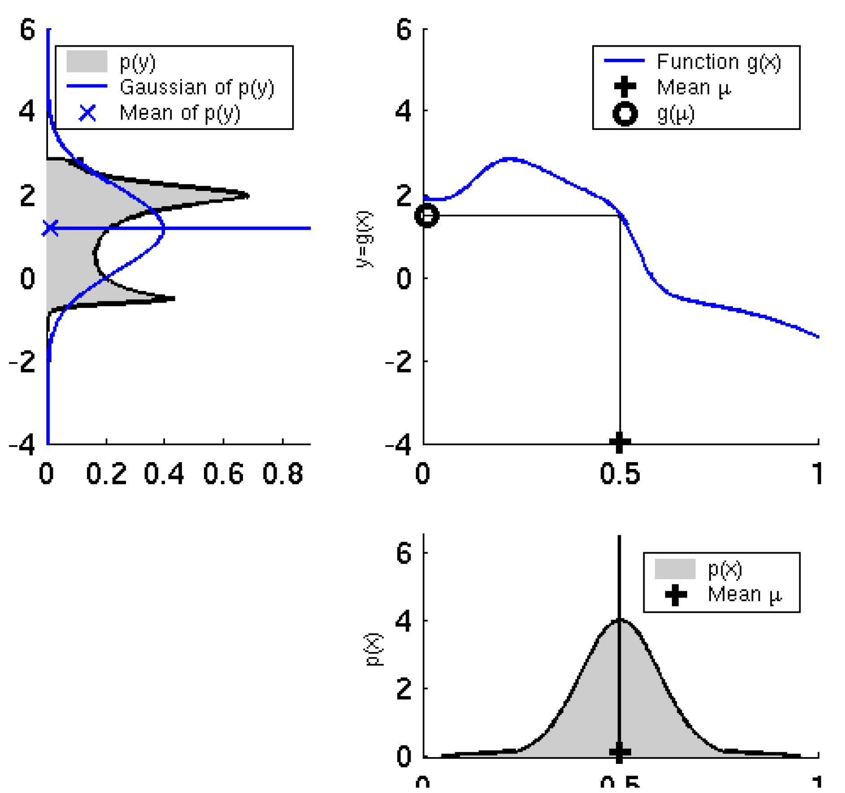

Fig 1.

I followed the same sampling procedure, but the *g* function I used is from the prediction step of EKF localization [1]:

*g*:



Here are some special examples when trying different parameters.



Fig 2. If we follow the EKF, and take the jacobian at , then the approximated normal distribution will be a peak at . Therefore, the approximation is far different from the real distribution and relies on the noise term to compensate for this.



Fig 3. The resulting distribution contains a high peak, which is caused by the declining slope circled in red. Above that peak is a sharp descend. The example from text book in Fig 1. also has the similar situation. Thus, if the *g* function is nonlinear and possesses convex or concave shape, the real distribution will contain such a peak, which is very different from the linear Gaussian approximation.

 

1. (b)

Fig 4. By adjusting the, (a) withand (b) with, the *g* function becomes “flatter” as and the real distribution is almost similar to a Gaussian distribution. Smaller, i.e. higher frame rate, can get better approximation result and get smaller variance in resulting Gaussian distribution (see blue arrows).

From the above observations, the following factors can make the EKF in this context perform better (smaller linearization error). 1) Higher frame rate makes the result variance smaller and much similar to gaussian distribution. 2) If we can possibly make the variance of the belief smaller, then in linearized error propagation the peak can better avoid the area where *g’* is nearly 0 (the error is usually larger here).

On the other hand, different parametrization may lead to different linearity. Civera et al. proposed to use inverse depth to represent the feature’s state for monocular SLAM [2]. Also, they proposed a linearity index to analyze how linear the propagation function *f* is at some particular situation. The smaller the *L*, the higher the linearity. In their analysis, inverse depth has higher linearity for features with high and low parallax than traditional XYZ parametrization.

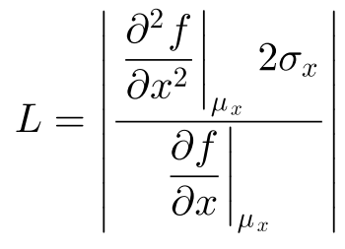

1. Noise tuning (Q, R)

From the previous result or lecture, the noise term not only reflect the real error from the sensor or actuator but is used to compensate the linearization error. Thus, usually we have to tune it so as to get better performance and not to make the system over confident.

Here is an example when I was tuning the noise of motion model for monocular SLAM.

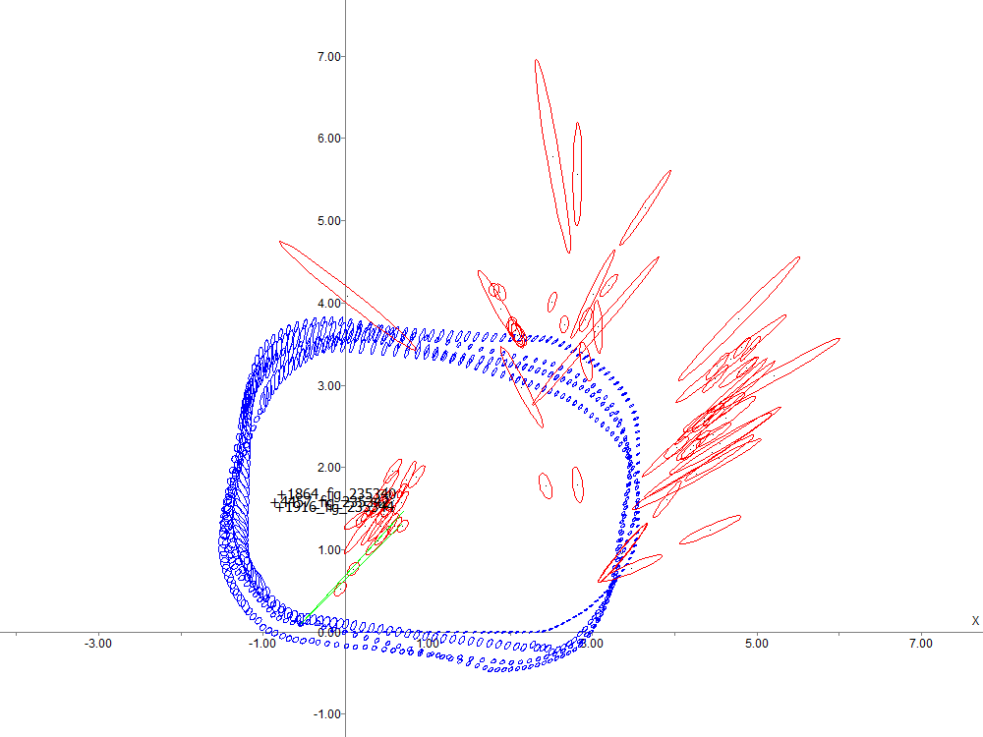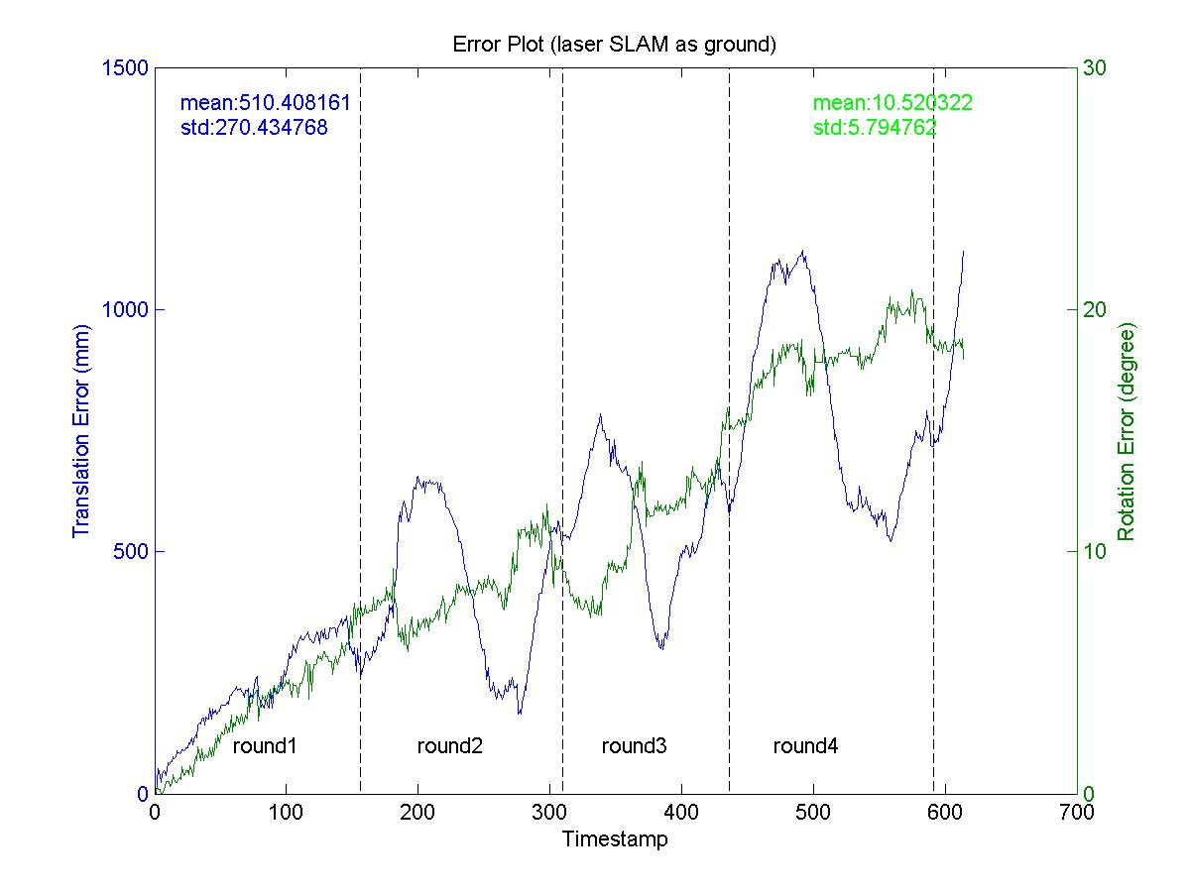

Fig 5. Before adjustment, the noise terms are (0.03m)2/1m (distance error) and (2deg)2/360deg (rotational error). *Left*: The red circles denote the features, and the blue circles denote the robot trajectory (the circles are  bound so as to show clearer robot trajectory). The robot followed the same path (dashed rectangle) for 4 rounds. Black solid line is the room boundary. The camera is facing 45 degree to the front left. *Right*: the localization error against ground truth is diverging.

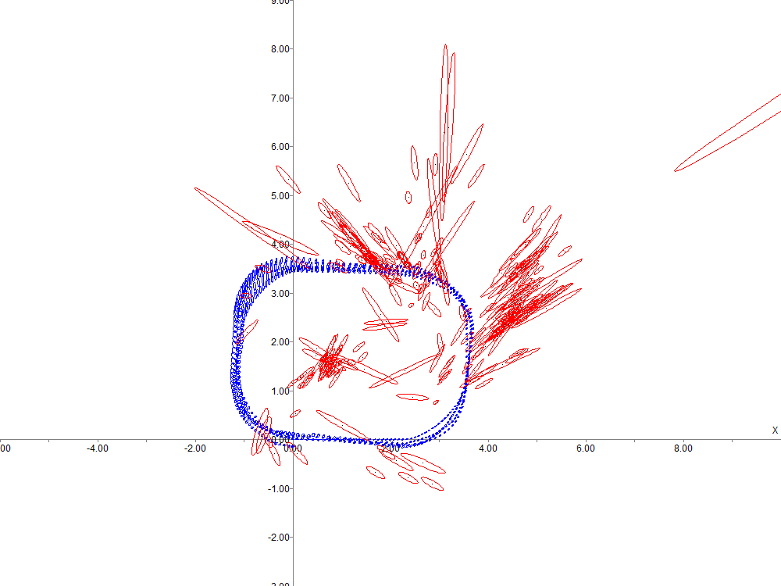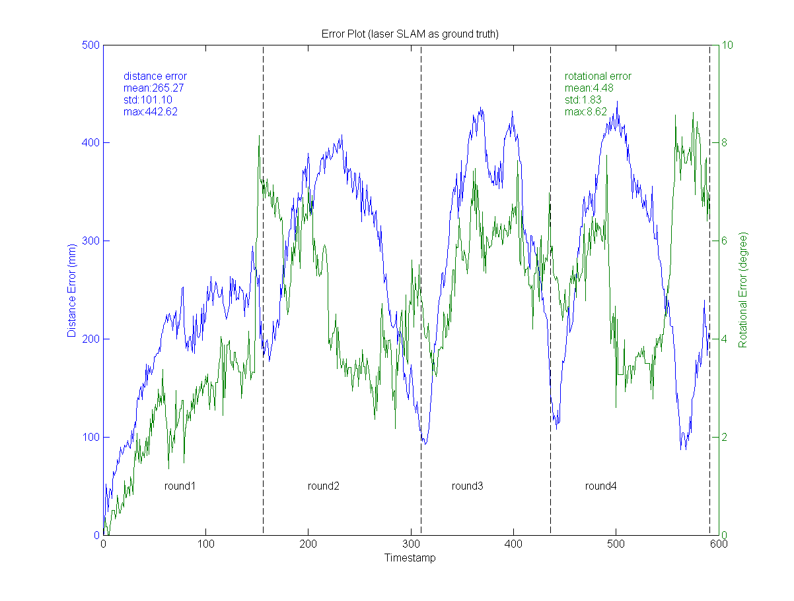

Fig 6. After adjustment, the noise terms are (0.01m)2/1m (distance error) and (3deg)2/360deg (rotational error). The adjustment is due to that I found out the odometry reading from our platform have relatively higher rotational error than translation error. The localization error against ground truth now is not diverging.

In this monocular SLAM system, we use delayed landmark initialization. If the robot has high uncertainty in localization, then the observed feature’s bearing also have a higher uncertainty, and thus it is unlikely to initialize landmarks. But, if we adjust the noise to be as smaller as possible, the robot localization is more certain, the features are then more certain in bearing and consequently more landmarks are initialized. Sufficient number of landmarks is crucial for the SLAM result.

[1] S. Thrun *et al*. Probabilistic Robotics, p205.

[2] Javier Civera, Andrew J. Davison, and J. M. Mart´ınez Montiel. Inverse Depth Parametrization for Monocular SLAM.