2.

|  |  |  |  |
| --- | --- | --- | --- |
|  | sunny | cloudy | rainy |
| Day1 | 1 | 0 | 0 |
| Day2 | 0.8 | 0.2 | 0 |
| Day3 | 0.8*0.8+0.2*0.4  =0.72 | 0.8*0.2+0.2*0.4  =0.24 | 0.8*0+0.2*0.2  =0.04 |
| Day4 | 0.72*0.8+0.24*0.4+  0.04*0.2  =0.68 | 0.72*0.2+0.24*0.4+  0.04*0.6  =0.264 | 0.72*0+0.24*0.2+  0.04*0.2  =0.056 |

(a)







(b)

function A = genW(n)

t = [.8 .2 .0; .4 .4 .2; .2 .6 .2];

A = zeros(n,1);

A(1) = 1;

for i = 2:n

r = rand();

if r < t(A(i-1),1)

A(i) = 1; % sunny

elseif r < t(A(i-1),2)+t(A(i-1),1)

A(i) = 2; % cloudy

else

A(i) = 3; % rainy

end

end

end

(c)

function x=staticP(A)

n = size(A,1);

ntype = 3;

x = [sum(A ==1), sum(A ==2), sum(A==3)];

x = x/n;

end

>> ps=staticP(genW(2000000))

ps =

0.6431 0.2855 0.0714







(d)



By solving



We can get :



(e)

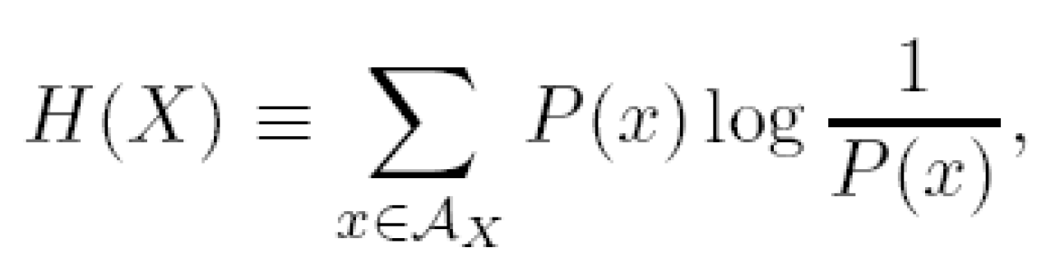

H(X) = -0.6431*log(0.6431) - 0.2855*log(0.2855) - 0.0714*log(0.0714) = 1.1978

(f)

ps =[9 4 1]/14;

T = [.8 .2 .0; .4 .4 .2; .2 .6 .2];

r = [ps' ps' ps'] .* T';

r(1,:) = r(1,:)./sum(r(1,:));

r(2,:) = r(2,:)./sum(r(2,:));

r(3,:) = r(3,:)./sum(r(3,:));

r =

0.5714 0.2857 0.1429

0.1667 0.3333 0.5000

0 0.5000 0.5000

|  |  |  |  |
| --- | --- | --- | --- |
| today\yesterday | sunny | cloudy | rainy |
| sunny | 0.5714 / 0.8 | 0.2857 / 0.1778 | 0.1429 / 0.0222 |
| cloudy | 0.1667 /0.45 | 0.3333 / 0.4 | 0.5000 / 0.15 |
| rainy | 0 | 0.5000 / 0.8 | 0.5000 /0.2 |



(g)

Markov assumption says the current state only depends on the previous state. However, the dynamic transition function does not violate the rule.

3.

(a)

Using the bayes filter implemented with matlab code, 



x = [1 0 0];

Pzx = [.6,.4,.0;.3,.7,.0;0,0,1]';

Pxx = [.8 .2 .0; .4 .4 .2; .2 .6 .2]';

z = [0,2,2,3,1];

for i=2:5

xp = zeros(1,3);

for j=1:3

for k=1:3

xp(j) = xp(j) + Pzx(z(i),j)*Pxx(j,k)*x(i-1,k);

end

end

xp = xp/sum(xp);

x = [x;xp];

end

x =

1.0000 0 0

0.6957 0.3043 0

0.5977 0.4023 0

0 0 1.0000

0.4000 0.6000 0

(where x(i,j) = P(jth weather on ith day ), 1st weather is sunny, 2nd is cloudy, 3rd is rainy.)

(b)

1) Only the data available to the day is used:

Using the above program we can generate the possibility,

x =

1.0000 0 0

0.8889 0.1111 0

0.8718 0.1282 0

0 0 1.0000

(where x(i,j) = P(jth weather on ith day ), 1st weather is sunny, 2nd is cloudy, 3rd is rainy.)

Therefore, the most likely weather on 2nd day is sunny, on 3rd day is sunny, and 4th day is rainy.

2) Data from future is available:

Because the measurement for rainy is always perfect, we can infer that the 4th day must be rainy. After that, we can infer that 3rd day must be cloudy by using the result from 2.f. and perfect measurement for rainy. Then we left two choices, (2nd = cloudy) or (2nd = sunny).





So, day 2 is more likely to be sunny.

(c)

From the previous inference from both passed and future data, there are only two possibilities: (cloudy, cloudy, rain) or (sunny, cloudy, rain). By normalizing the probability,



