1. **Chapter 10, Exercise 2**

**Why initialization is a problem in bearing only SLAM?**

The reason why initialization of landmark is an important issue is because there is no direct depth information from the bearing-only sensor. Therefore, the possible location of a newly observed landmark lies in a cone shape region. After several observation and updates, the region will converge into a closed region. However, traditional Gaussian distribution in XYZ space cannot provide a unified representation of these two kinds of probability distribution.

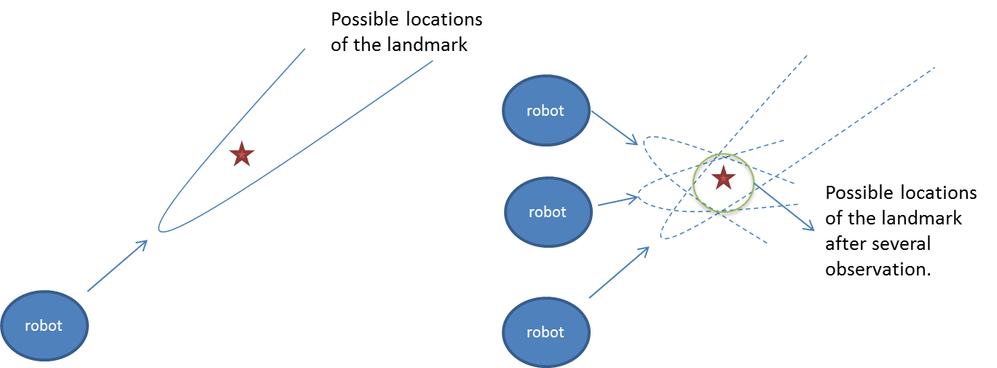

**Landmark Initialization**

Here I will describe the Inverse depth method proposed by Civera *et al.* It is a unified representation can initialize the landmark without delay.

On first observation, 6 parameters are used to represent the landmark state:, where each terms are described in the figure below.

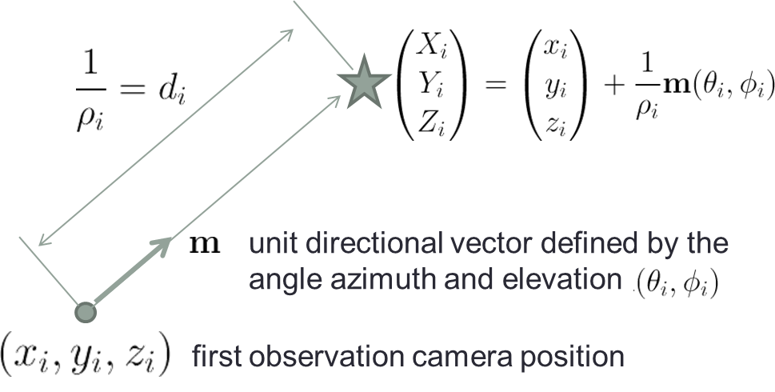

The camera pose can be easily obtained. We can also compute  using the camera parameters. For the inverse depth,  is assigned a general Gaussian prior in inverse depth that encodes probabilistically the fact that the point has to be in front of the camera.



which means

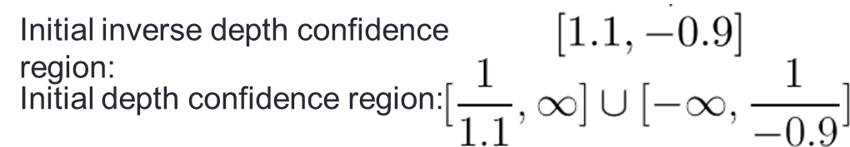

With the probabilistic framework (e.g. EKF), we can keep on updating the state. After the uncertainty reduced, the possible region of landmark location will form a closed space.

1. **Chapter 12, Exercise 4**

**Why?**

Because we assume that the variable xt does not depend on the passive features m- if we know the active features m0 and m+. Therefore, we can set m- to arbitrary value without affecting the conditional posterior.

**What would be the update equation if these features would not be conditioned away?**

If these features are not conditioned away, we should do a full EIF update (without multiplying the F-matrix).

**Would the result be more accurate or less accurate?**

The result would be more accurate if we conduct a full EIF update. On the other hand, if we perform the SEIF update without conditioning m- away, the result should be less accurate because some information of some link is arbitrarily ignored.

**Would the computation be more or less efficient?**

Less efficient. If we conduct the full EIF update, the efficiency is similar to EKF.

**(c) Chapter 13, Exercise 1.**

**EKF**

1. Using Gaussian distribution to represent the states makes the computation very fast.
2. No need to sample among the state distribution.
3. Capable to consider uncertainty over high dimensional state. In contrast, the number of particles required by particle filter increase exponentially.

**GraphSLAM**

1. Solve the full SLAM problem. It calculates posteriors over the full robot path along with map.
2. Consider data association with probability.
3. Incorporate sparsification idea by using information matrix.

**FastSLAM**

1. Multiple hypothesis tracking through per-particle data association.
2. Use sampling on highly non-linear portions of state space can avoid linearization error using EKF.
3. Particle filter is generally easier to implement.

(c) Chapter 13, Exercise 7.

Fast slam simulation

Red: ground truth

Blue: particles

Green: landmarks



The following figure shows the strength of the correlations w.r.t timestep. At the beginning, the strength increases with time. This means the uncertainty increases. At time=72, the robot back to the starting point (20, 0), the strength reach the nadir. The situation is similar to the decrease of variance when closing a loop in EKF.



function fastslamProcedure

global Y;

global setting;

global landmark;

global x_groundtruth;

setting.nstep = 100;

setting.nparticle = 100;

setting.zrange = 10000;

setting.nlandmark = 100;

setting.Usigma = 0.1;

setting.Zsigma = 0.1;

%setting.Usigmath = 0.01;

%setting.R = [0.1 0 0; 0 0.1 0; 0 0 0.01];

setting.R = [0.5 0; 0 0.5];

initLandmark();

initParticle(); %draw init samples

x_groundtruth = generate_x_groundtruth();

for i=2:setting.nstep

[u z c] = simulateOneStep(x_groundtruth,i);

%for j=1:length(c)

Y{i} = FastSlam(z,c,u,Y{i-1});

%end

end

drawY();

fitGaussian();

end

function fitGaussian()

global Y setting

f = zeros(0,2);

for kk = 1:setting.nstep

data = zeros(setting.nparticle,2+setting.nlandmark*2);

for i=1:setting.nparticle

data(i,1:2) = Y{kk}.p{i}.xt;

for j=1:setting.nlandmark

if(Y{kk}.p{i}.landmark{j}.init==1)

data(i,2+(j-1)*2 : 2+(j-1)*2+1) = Y{kk}.p{i}.landmark{j}.mu;

end

end

end

avg = mean(data);

Cov = zeros(2+setting.nlandmark*2);

for i=1:(2+setting.nlandmark*2)

for j=1:(2+setting.nlandmark*2)

for k=1:setting.nparticle

Cov(i,j) = Cov(i,j) + (data(k,i)-avg(i))*(data(k,j)-avg(j));

end

end

end

Cov = Cov/setting.nparticle;

f = [f;kk norm(Cov)];

end

figure

plot(f(:,1),f(:,2));

end

function drawY()

global Y x_groundtruth landmark

figure

hold on;

for i=1:length(Y)

for j=1:length(Y{i}.p)

plot(Y{i}.p{j}.xt(1),Y{i}.p{j}.xt(2), 'b.');

end

pause(0.1);

plot(x_groundtruth(i,1),x_groundtruth(i,2), 'r*');

end

for i=1:size(landmark,1);

plot(landmark{i}(1),landmark{i}(2),'g*');

end

end

function Yt = FastSlam(z, c, u, Yt_1)

global setting;

Yt.p = cell(length(Yt_1.p),1);

for k=1:length(Yt_1.p) % loop over particles

pstate = Yt_1.p{k};

xt = pstate.xt + u+ randn(1,2)*setting.Usigma*2;

Yt.p{k}.landmark = pstate.landmark;

Yt.p{k}.w = 0;

for j=1:length(c)

j_lmk = c(j);

if Yt.p{k}.landmark{j_lmk}.init == 0 % j never seen before

mu = z(j,1:2) + xt; % initialize mean

invG = invgp(xt, mu);

Cov = invG*setting.R*invG';

Yt.p{k}.landmark{j_lmk}.mu = mu;

Yt.p{k}.landmark{j_lmk}.Cov = Cov;

Yt.p{k}.landmark{j_lmk}.init = 1;

Yt.p{k}.w = Yt.p{k}.w+0.9;

else

Cov = Yt.p{k}.landmark{j_lmk}.Cov;

mu = Yt.p{k}.landmark{j_lmk}.mu;

zt = z(j,1:2);

zh = mu-xt; %g(mu, xt);

G = gp(xt,mu);

Q = G'*Cov*G + setting.R;

K = Cov*G*Q;

mu = mu + (K* (zt-zh)')';

Cov = (eye(2) - K*G') * Cov;

Yt.p{k}.landmark{j_lmk}.Cov = Cov;

Yt.p{k}.landmark{j_lmk}.mu = mu;

%Yt.p{k}.w = exp(-(zt-zh)*(zt-zh)');

Yt.p{k}.w = Yt.p{k}.w+(1/sqrt(det(2*pi*Q))) * exp(-0.5*(zt-zh)*inv(Q)*(zt-zh)');

end

Yt.p{k}.xt = xt;

end

end

Yttmp = Yt;

corr = zeros(setting.nparticle, 1);

corr(1) = Yt.p{1}.w;

for i=2:setting.nparticle

corr(i) = corr(i-1) + Yt.p{i}.w;

end

RAND = rand(setting.nparticle,1)*corr(setting.nparticle);

for i=1:setting.nparticle

j=0;

for j=1:setting.nparticle

if j==1, ub = 0;

else ub = corr(j-1);

end

if RAND(i) < corr(j) && RAND(i) >= ub;

break;

end

end

Yt.p{i} = Yttmp.p{j};

end

end

function x = gp(xt, mu)

x = [1 0; 0 1];

end

function x = invgp(xt, mu)

x = [1 0; 0 1];

end

function x_groundtruth = generate_x_groundtruth()

global setting

x_groundtruth = zeros(setting.nstep, 2);

for i=1:setting.nstep

x_groundtruth(i,1:2) = [cos((i-1)*pi/36), sin((i-1)*pi/36)] * 20;

%x_groundtruth(i,3) = i*pi/36; % 5 degree each step

end

end

function [u,z,c] = simulateOneStep(x_groundtruth, index)

global landmark;

global setting;

u = x_groundtruth(index,:) - x_groundtruth(index-1,:)+ [randn(1,2)*setting.Usigma]; % R

c = zeros(0,1);

z = zeros(0,2);

for i=1:length(landmark)

dist = norm( landmark{i} - x_groundtruth(index,1:2) );

if(dist < setting.zrange) %% visible

z = [z; (landmark{i} - x_groundtruth(index,1:2))] ;

c = [c; i];

end

end

end

function initLandmark()

global setting landmark;

landmark = cell(setting.nlandmark,1);

rnd = rand(setting.nlandmark,2);

for i=1:setting.nlandmark

landmark{i} = rnd(i,:)*40-[20,20];

end

end

function initParticle()

global Y;

global setting;

global landmark;

Y = cell(setting.nstep,1);

Y{1}.p = cell(setting.nparticle,1);

initLandmarkSigma = [0.1^2 , 0, 0, 0.1^2];

for k=1:setting.nparticle

Y{1}.p{k}.xt = [20 0];

Y{1}.p{k}.landmark = cell(setting.nlandmark,1);

Y{1}.p{k}.w = 1/setting.nparticle;

for i=1:setting.nlandmark

Y{1}.p{k}.landmark{i}.init = 0;

%Y{1}.p{k}.landmark{i}.u = landmark{i};

%Y{1}.p{k}.landmark{i}.Sigma =initLandmarkSigma;

end

end

end